Contact Management System CMS code

import csv

contacts = {
"John Doe": {
"phone": "+1234567890",
"email": "don@example.com",
"address": "123 Main St",
"group": "Friends"
},
"Jane Smith": {
"phone": "+0987654321",
"email": "jane@example.com",
"address": "456 Oak Ave",
"group": "Work"
}
}

def add_contact():
name = input("Enter name: ")
phone = input("Enter phone: ")
email = input("Enter email: ")
address = input("Enter address: ")
group = input("Enter group (Friends/Work/Family): ")

contacts[name] = {
"phone": phone,
"email": email,
"address": address,
"group": group
}
print("Contact added successfully!")

def search_contact():
keyword = input("Enter name to search: ").lower()
results = []

for name, details in contacts.items():
if keyword in name.lower():
results.append((name, details))

if results:
print(f"\nSearch Results for '{keyword}':")
print("-" * 42)
for i, (name, d) in enumerate(results, 1):
print(f"{i}. {name}")
print(f" Phone: {d['phone']}")
print(f" Email: {d['email']}")
print(f" Address: {d['address']}")
print(f" Group: {d['group']}\n")
print(f"Found {len(results)} contacts matching '{keyword}'")
else:
print("No contacts found.")

def update_contact():
name = input("Enter contact name to update: ")
if name in contacts:
contacts[name]["phone"] = input("New phone: ")
contacts[name]["email"] = input("New email: ")
contacts[name]["address"] = input("New address: ")
contacts[name]["group"] = input("New group: ")
print("Contact updated successfully!")
else:
print("Contact not found.")

def delete_contact():
name = input("Enter contact name to delete: ")
if name in contacts:
del contacts[name]
print("Contact deleted successfully!")
else:
print("Contact not found.")

def view_all_contacts():
if not contacts:
print("No contacts available.")
return

for name, d in contacts.items():
print("-" * 30)
print(f"Name: {name}")
print(f"Phone: {d['phone']}")
print(f"Email: {d['email']}")
print(f"Address: {d['address']}")
print(f"Group: {d['group']}")

def export_to_csv():
with open("contacts.csv", "w", newline="") as file:
writer = csv.writer(file)
writer.writerow(["Name", "Phone", "Email", "Address", "Group"])
for name, d in contacts.items():
writer.writerow([name, d["phone"], d["email"], d["address"], d["group"]])
print("Contacts exported to contacts.csv")

def view_statistics():
total = len(contacts)
groups = {}

for d in contacts.values():
groups[d["group"]] = groups.get(d["group"], 0) + 1

print("\nStatistics:")
print(f"- Total Contacts: {total}")
for group, count in groups.items():
print(f"- {group}: {count} contacts")

def menu():
while True:
print("\n===========================================")
print(" CONTACT MANAGEMENT SYSTEM")
print("===========================================")
print("1. Add New Contact")
print("2. Search Contact")
print("3. Update Contact")
print("4. Delete Contact")
print("5. View All Contacts")
print("6. Export to CSV")
print("7. View Statistics")
print("8. Exit")

choice = input("Enter your choice (1-8): ")

if choice == "1":
add_contact()
elif choice == "2":
search_contact()
elif choice == "3":
update_contact()
elif choice == "4":
delete_contact()
elif choice == "5":
view_all_contacts()
elif choice == "6":
export_to_csv()
elif choice == "7":
view_statistics()
elif choice == "8":
print ("Exiting program. Goodbye!")
break
else:
print("Invalid choice. Please try again.")

if __name__ == "__main__":
menu ()
Contact Management System

Code

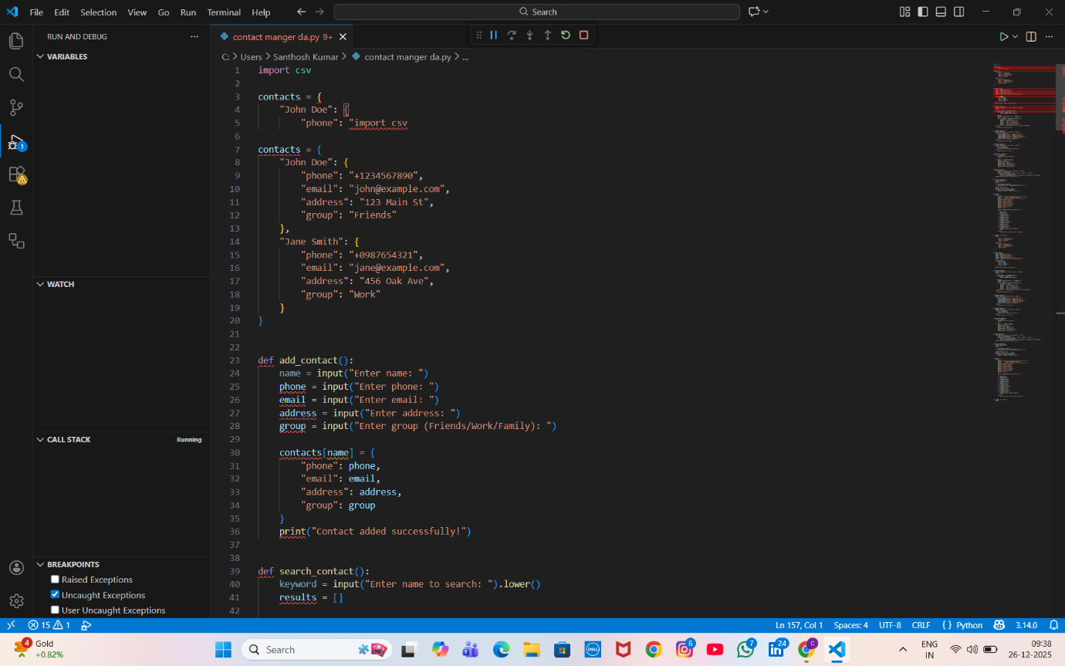
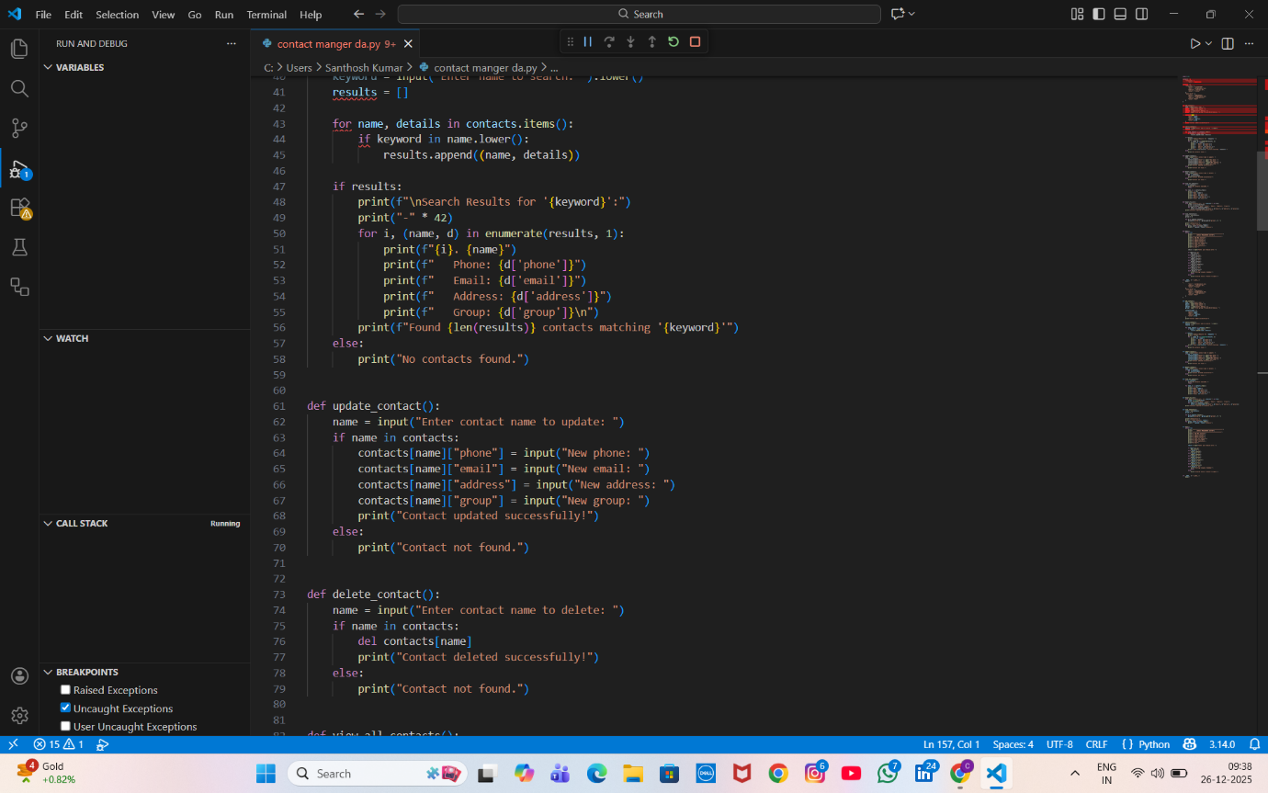
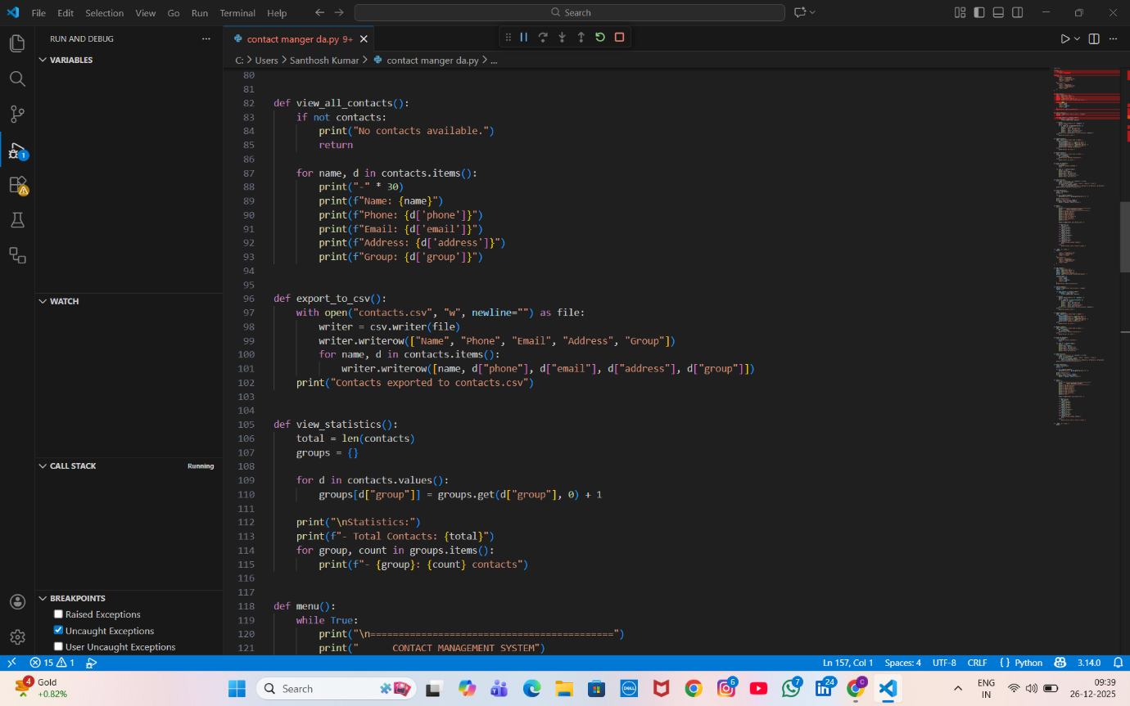
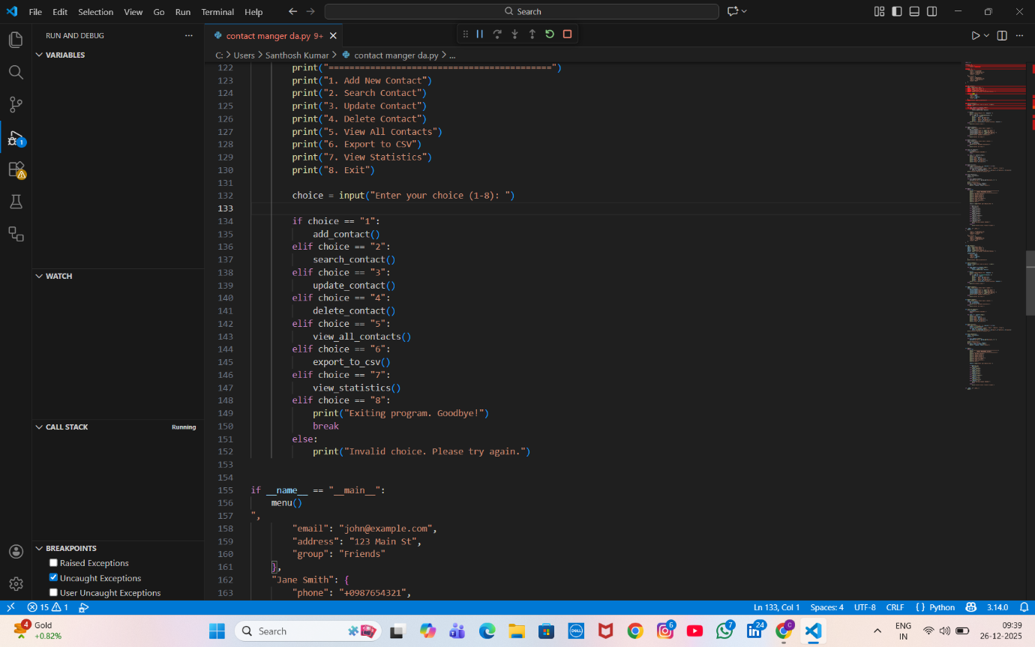
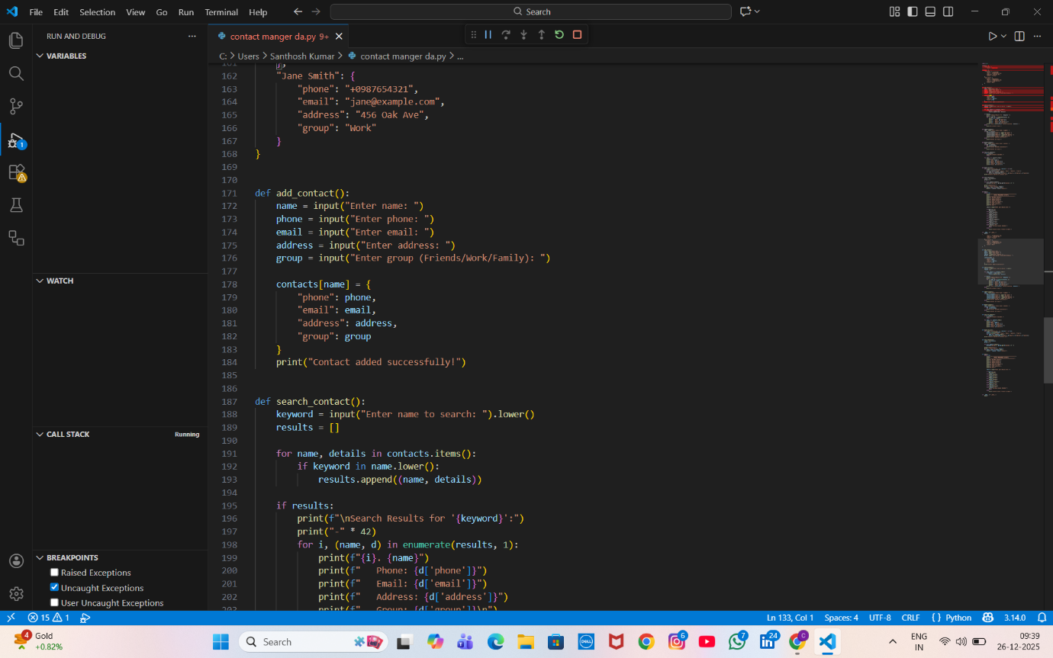

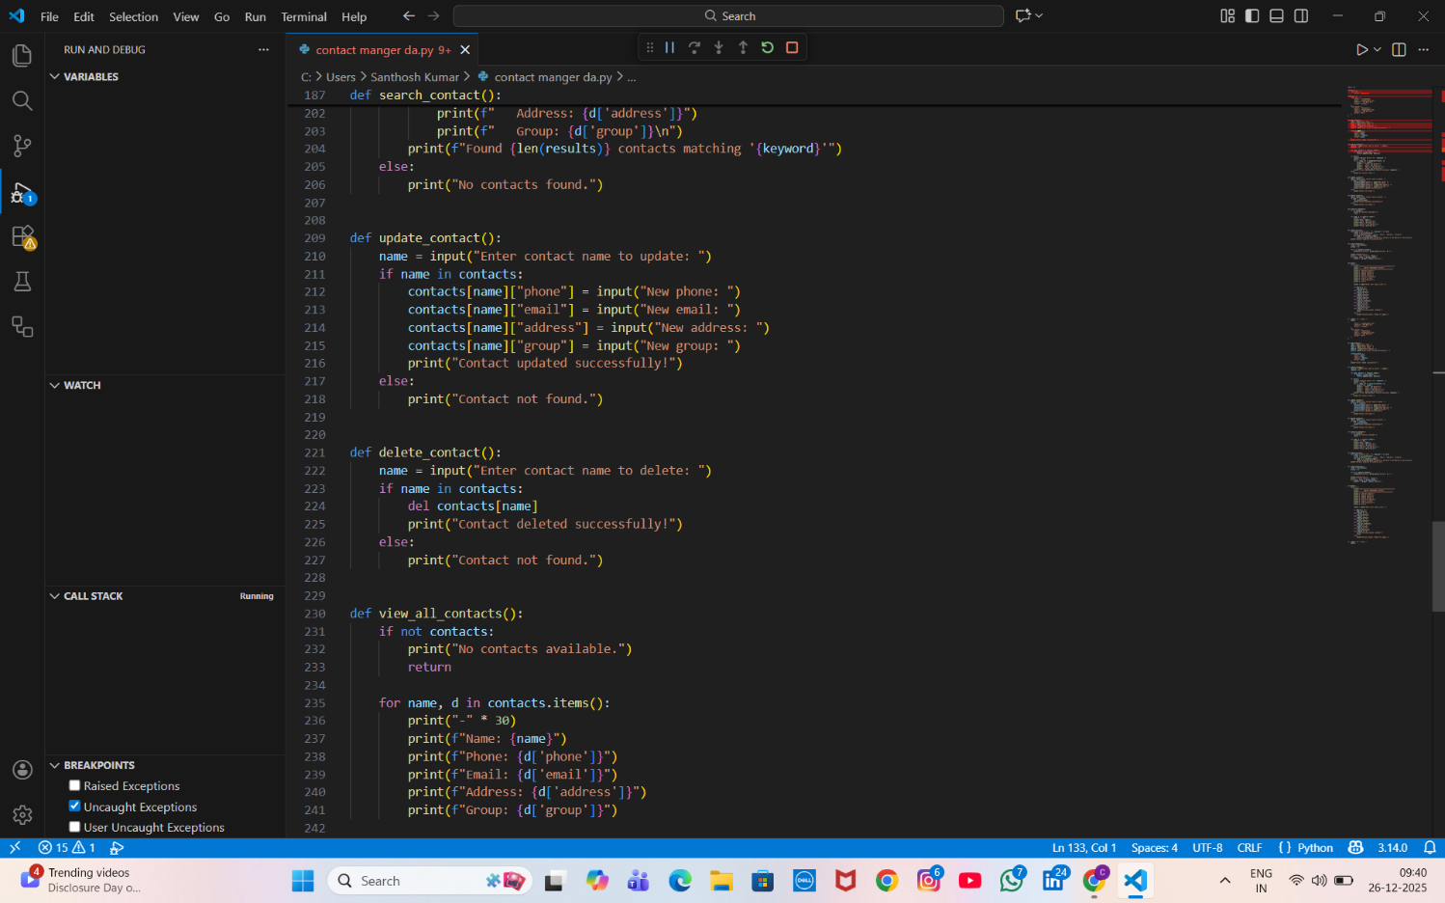
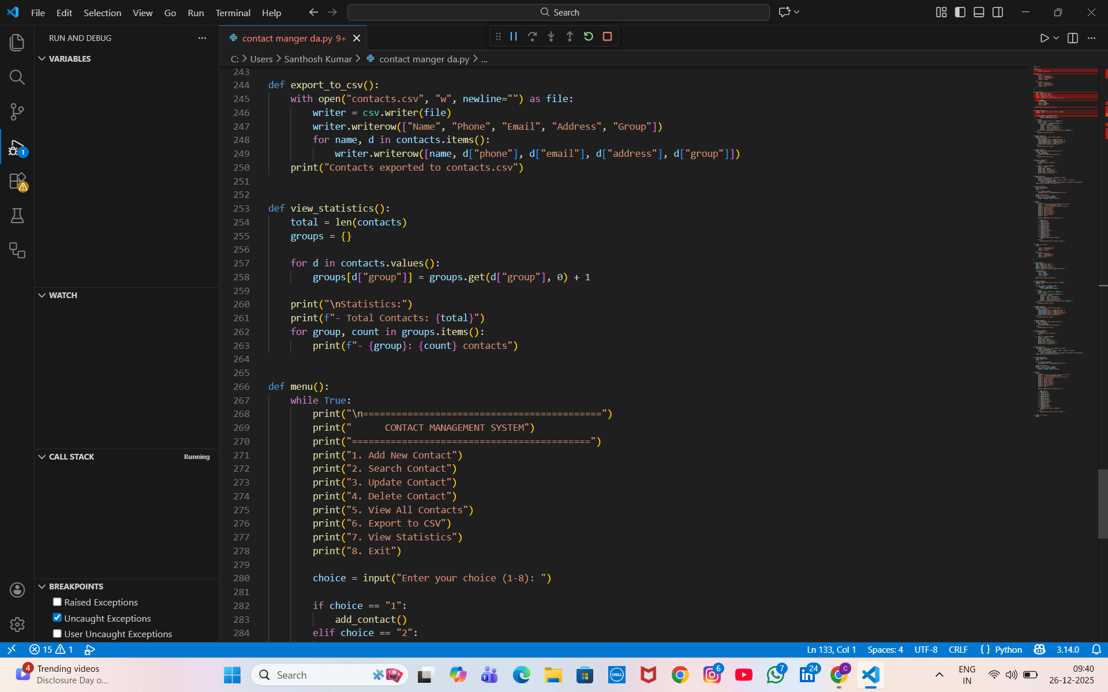

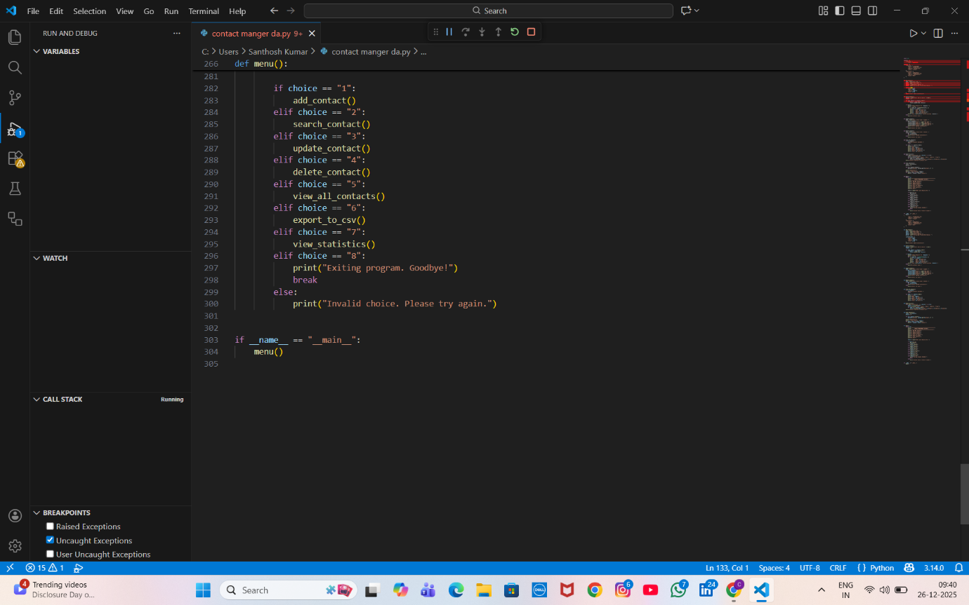
Out put
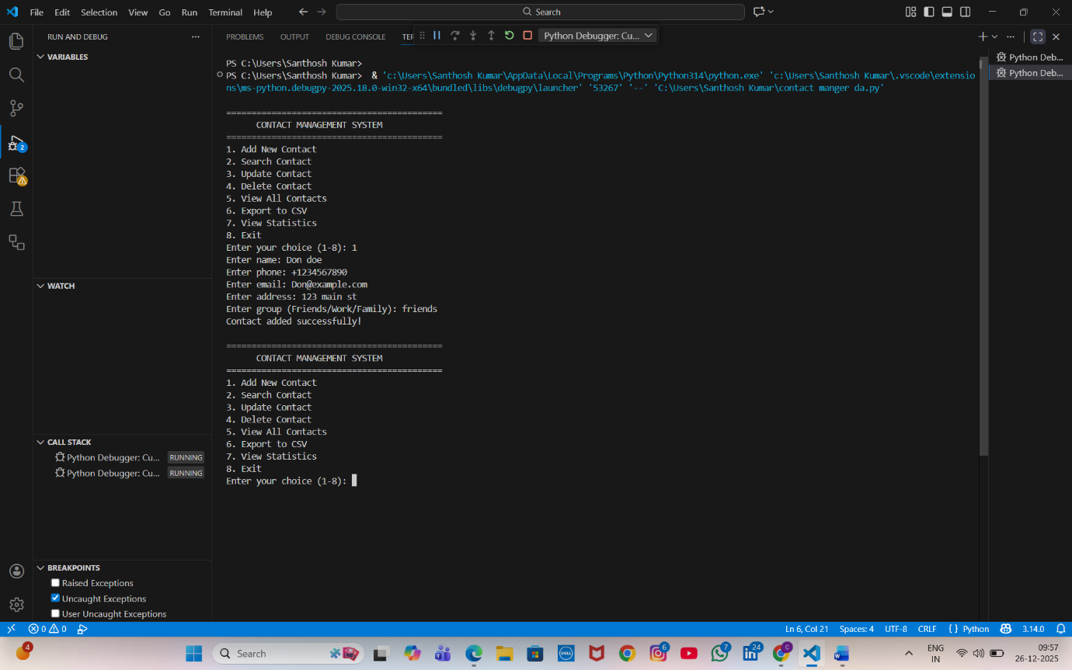

Contact Management System
Project Description
The Contact Management System is a Python-based application designed to efficiently store, manage, and organize contact information. The system uses dictionaries and functions to implement full CRUD operations (Create, Read, Update, Delete), along with search functionality and data persistence.
This project provides a user-friendly, menu-driven interface that allows users to manage contacts easily while ensuring data accuracy through validation and error handling. Contacts are automatically saved to a file, ensuring data is preserved between program runs.

What I Learned
Through this project, I gained practical experience with:
- Functions – Writing reusable and well-organized code
- Dictionaries – Storing and managing structured data using key-value pairs
- String Methods – Formatting and validating user input
- File Operations – Saving and loading data using JSON files
- Input Validation – Preventing incorrect or invalid data entry
- Error Handling – Handling unexpected user input and runtime errors gracefully
Features
- Add new contacts with input validation
- Search contacts by name (partial matching supported)
- Update existing contact details
- Delete contacts with confirmation
- View all contacts in a formatted layout
- Automatic saving of contacts to a JSON file
- Load contacts automatically on program startup
- Export contacts to CSV format
- Contact statistics and analytics
- Phone number and email validation
- User-friendly, menu-driven interface
- Robust error handling for all operations

How to Run
# Navigate to project folder
cd week3-contact-manager

# Install any requirements (if needed)
pip install -r requirements.txt

# Run the program
python contacts_manager.py

# Run tests
python test_contacts.py

Data Structure
contacts = {
"Don Doe": {
"phone": "+1234567890",
"email": "john@example.com",
"address": "123 Main St",
"group": "Friends"
},
"Jane Smith": {
"phone": "+0987654321",
"email": "jane@example.com",
"address": "456 Oak Ave",
"group": "Work"
}
}

Sample Menu
===========================================
CONTACT MANAGEMENT SYSTEM
===========================================
1. Add New Contact
2. Search Contact
3. Update Contact
4. Delete Contact
5. View All Contacts
6. Export to CSV
7. View Statistics
8. Exit

If you want, I can also help you with:
- Final project report
- Viva / oral exam questions
- Flowchart or UML diagram
- Web-based version
- Improved test cases

